VIRTUAL RESOURCES FOR IMMUNIZATION RECORDS

Did you know you can access & update your child’s immunization records online?

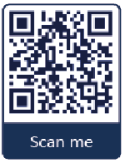
Access Records
Visit Health Gateway, a secure digital service from the Government of BC, to view and download official vaccination records - including COVID-19 and routine childhood immunizations. If your child was immunized at a public health unit, school, pharmacy, or community health centre their record should already be available. Records from first nations health centres, doctor's offices or outside BC may need to be submitted manually.

Visit www.healthgateway.gov.bc.ca or scan the QR code.

Update or Submit Records
If your child’s immunization record is incomplete, you can upload missing information through the Government of BC’s immunization record portal. Records must be in English, French, or a certified translation. After submitting, check in with your local public health unit within a few weeks to confirm the record is complete.

Submit missing records at www.immunizationrecord.gov.bc.ca

Questions?
Contact your local public health unit www.islandhealth.ca/our-locations/health-unit-locations

