KEEPING ACTIVE CHILDREN HYDRATED

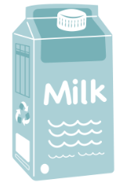
What fluids are best for my child?

- Water is the best choice
- Unsweetened cow’s milk (skim, 1%, 2%) and/or unsweetened fortified plant-based beverages (i.e., soy, almond, rice, oat, etc.)

What about fruit or vegetable juice?

Fruit juices can increase the risk of cavities in children and offer little nutritional value. If you offer juice, find one that says “100% juice” on the package and limit to ½ cup (125mL) per day. Serve it at meals or snacks to reduce the risk of cavities.

Some vegetable juices are high in sodium (salt). If offered, look for a lower sodium version.

Does my child need sports drinks or energy drinks when exercising?

No, sports drinks are usually not needed. For the average child, water should be the first choice for hydration before, during and after routine physical activity. If your child participates in prolonged and vigorous activity, a sports drink might be helpful.

Tip: Offer “watery” foods like watermelon, oranges, cucumber, or smoothies during and/or after activity, especially if you child finds it difficult to drink plain water.

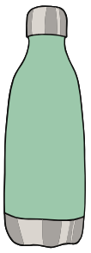
Energy drinks are not recommended for children and teens. Energy drinks are typically very high in sugar and caffeine. The amount of caffeine in these drinks is higher than the daily maximum deemed safe for children by Health Canada. Too much caffeine can cause difficulty sleeping, irritability, headaches, and nervousness.

Other tips to stay hydrated:

- Bring a reusable water bottle to school, outdoor activity, and sports
- Drink more water when it is very hot outside, and if you are sweating more than usual
- Flavour your water by adding cucumber, mint, berries, or apple chunks

For more information:

- HealthLink BC - Registered Dietitian Services: call 8-1-1 or email a Dietitian
- HealthLink BC - Energy and Sports Drinks
- Canadian Pediatric Society - Position Statement: Energy and sports drinks in children & adolescents

